**PROGRAM 4: STUDENT FACULTY DATABASE**

**Consider the following database for student enrollment for course :**

**STUDENT(snum: integer, sname: string, major: string, lvl: string, age: integer)**

**CLASS(cname: string, meets at: time, room: string, fid: integer)**

**ENROLLED(snum: integer, cname: string)**

**FACULTY(fid: integer, fname: string, deptid: integer)**

**The meaning of these relations is straightforward; for example, Enrolled has one record per student-class pair such that the student is enrolled in the class. Level(lvl) is a two character code with 4 different values (example: Junior: JR etc)**

**Write the following queries in SQL. No duplicates should be printed in any of the answers.**

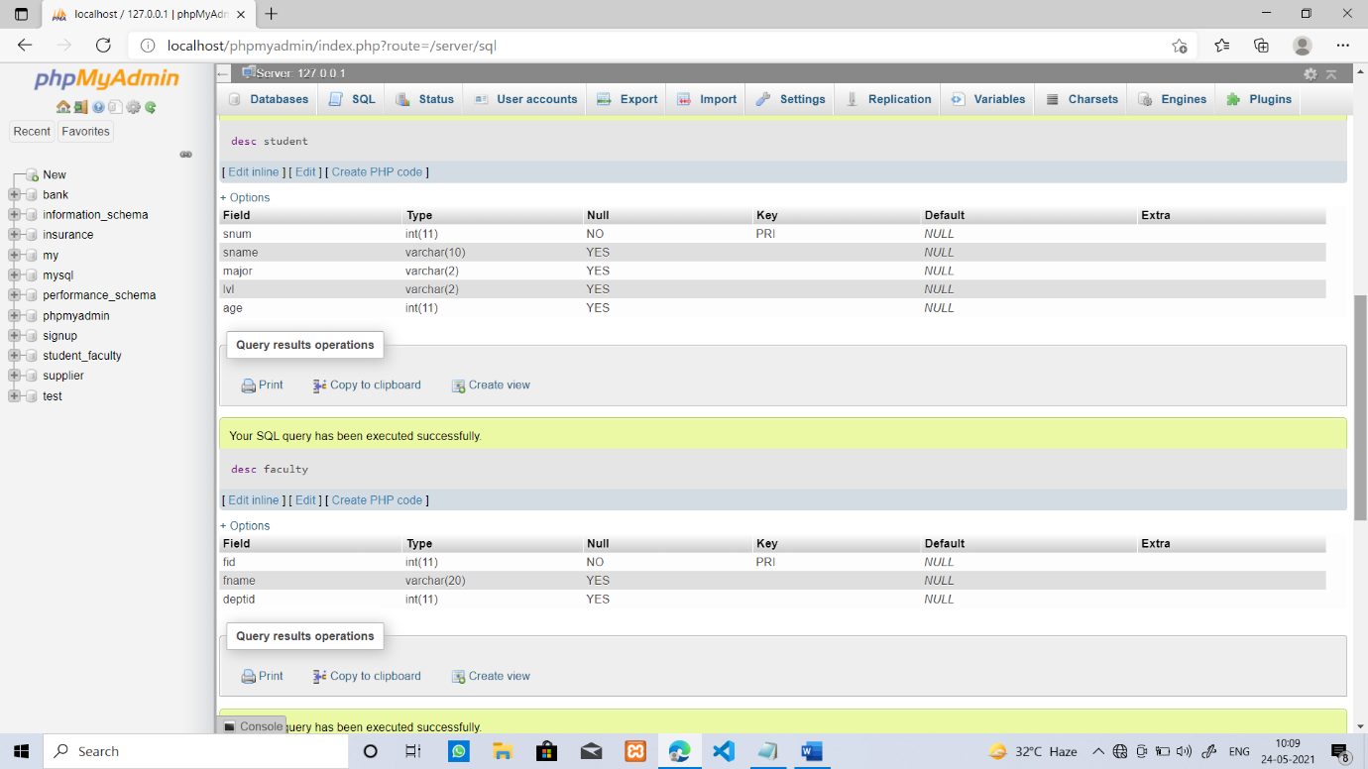

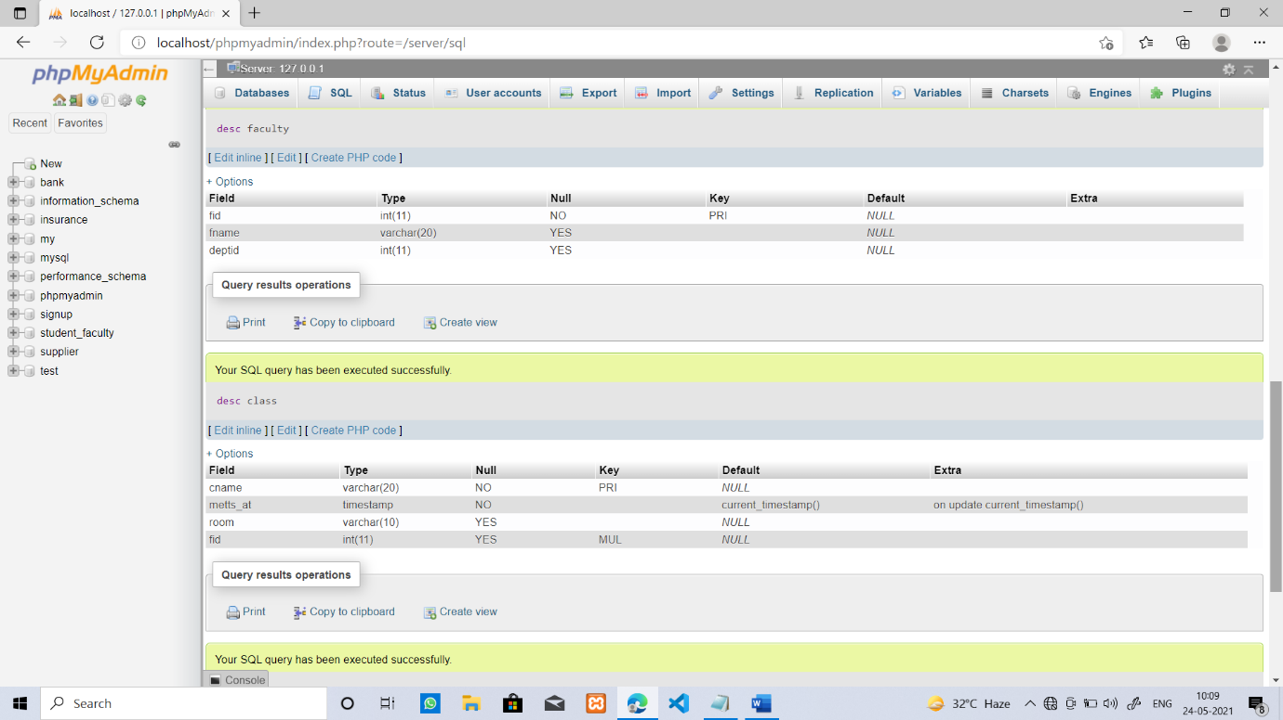

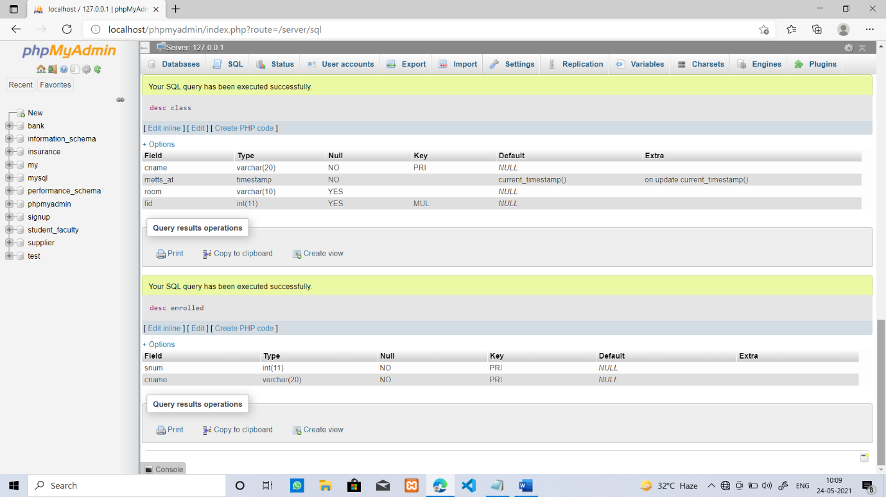

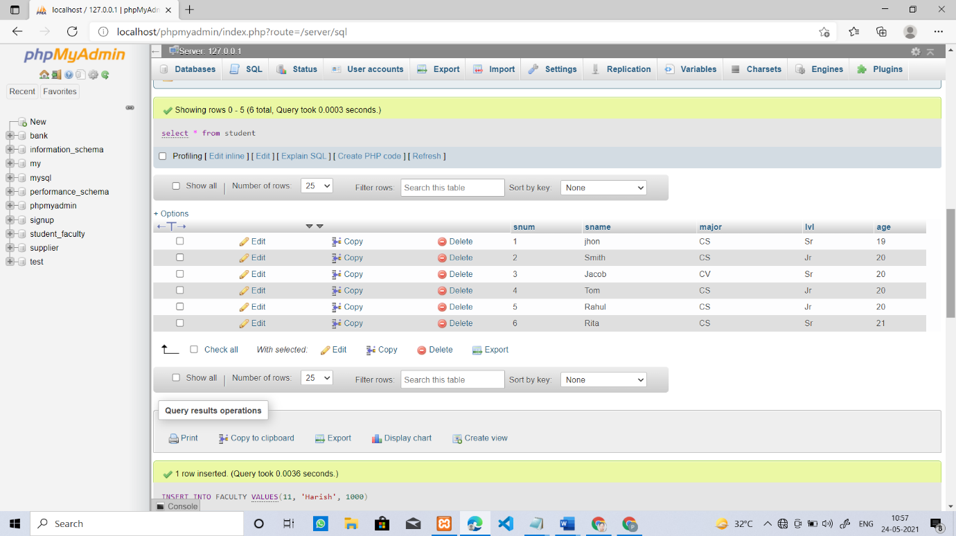

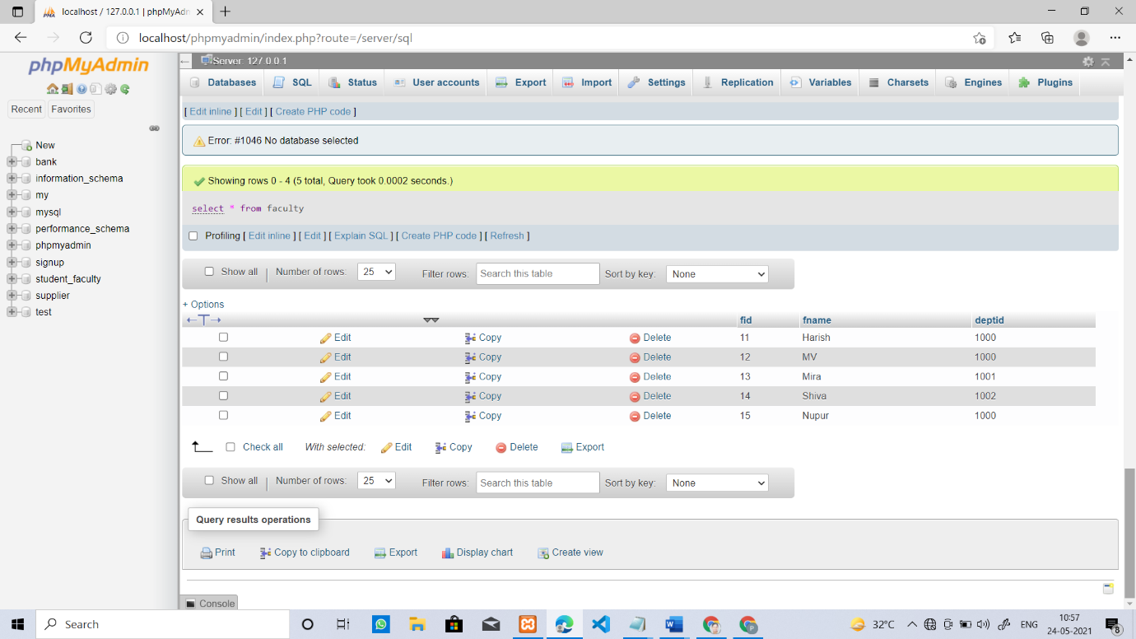

1. **Find the names of students who are not enrolled in any class.**

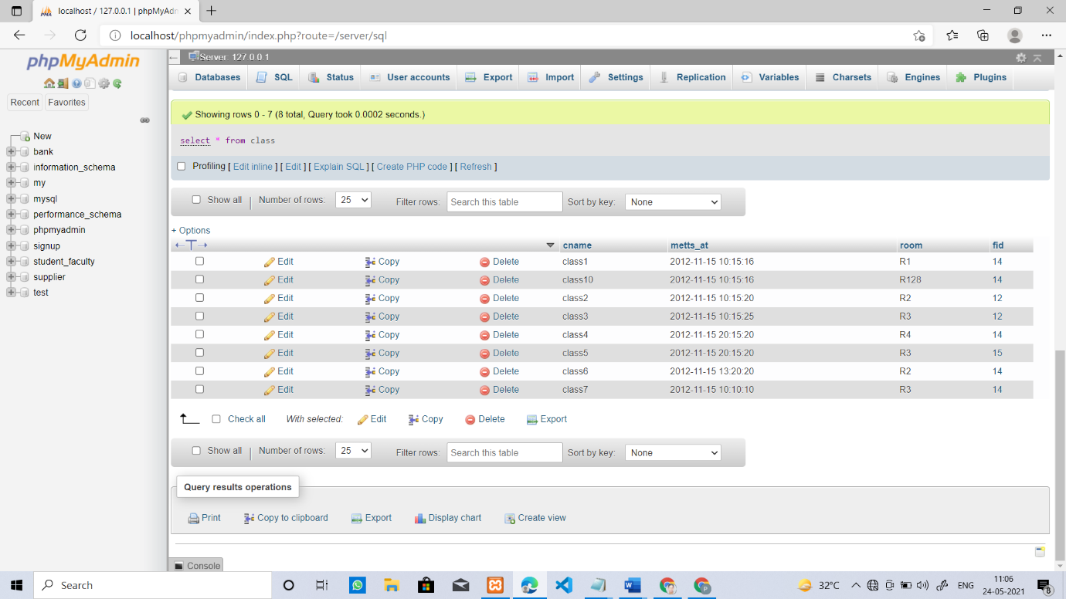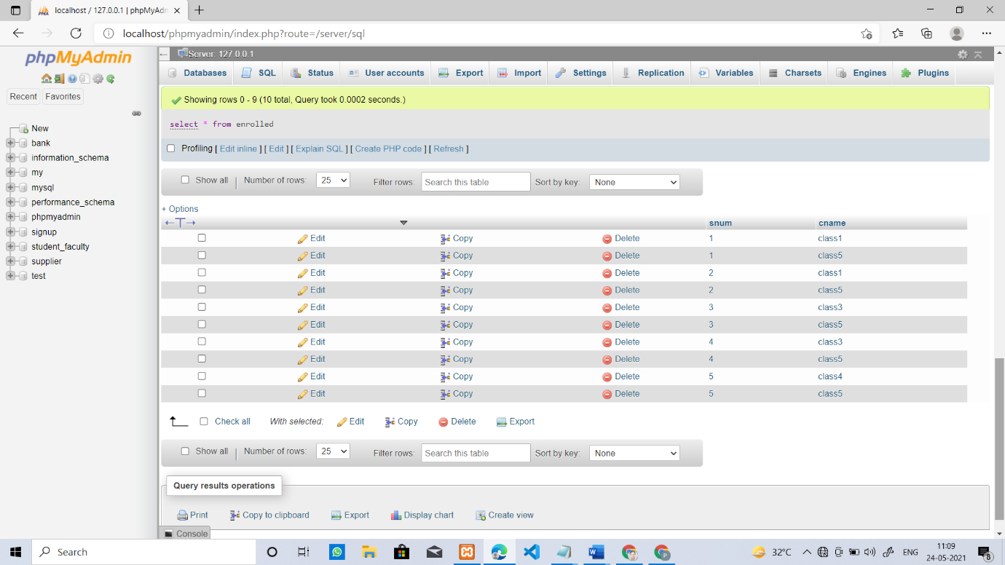

1. **Find the names of students who are not enrolled in any class.**

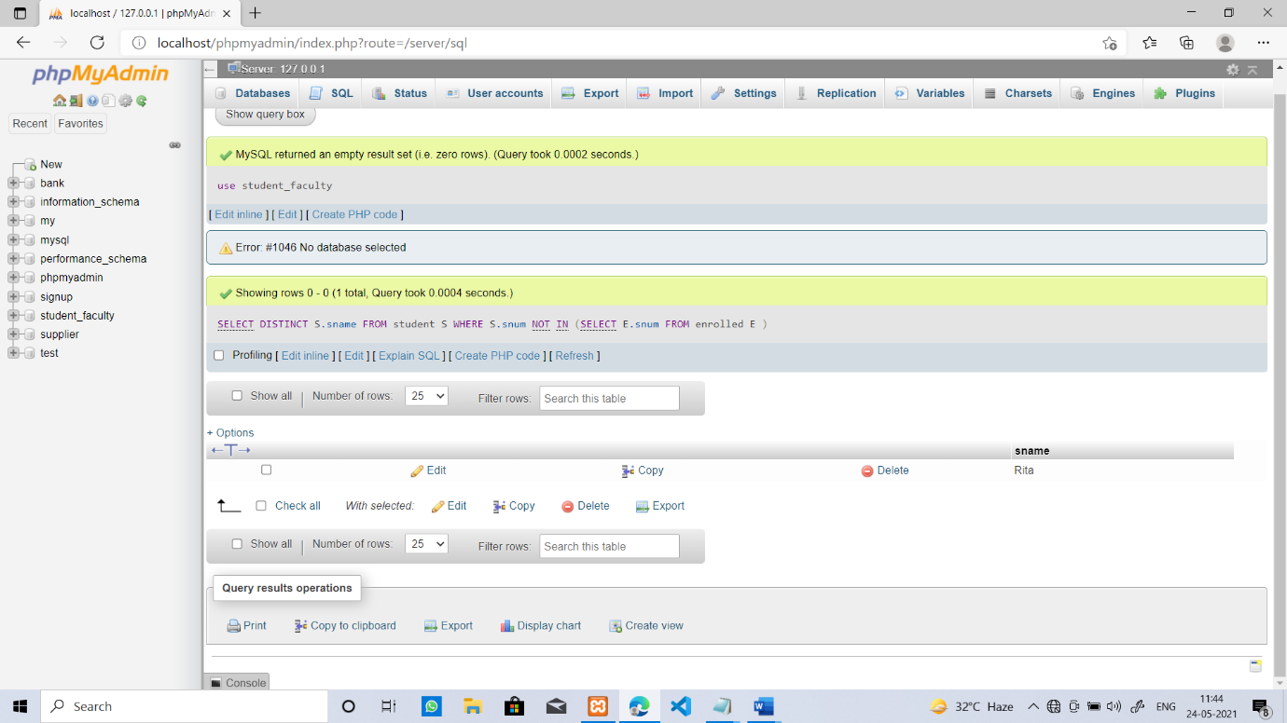

1. **For each age value that appears in Students, find the level value that appears most often. For example, if there are more FR level students aged 18 than SR, JR, or SO students aged 18, you should print the pair (18, FR).**
2. **Find the names of all classes that either meet in room R128 or have five or more Students enrolled.**

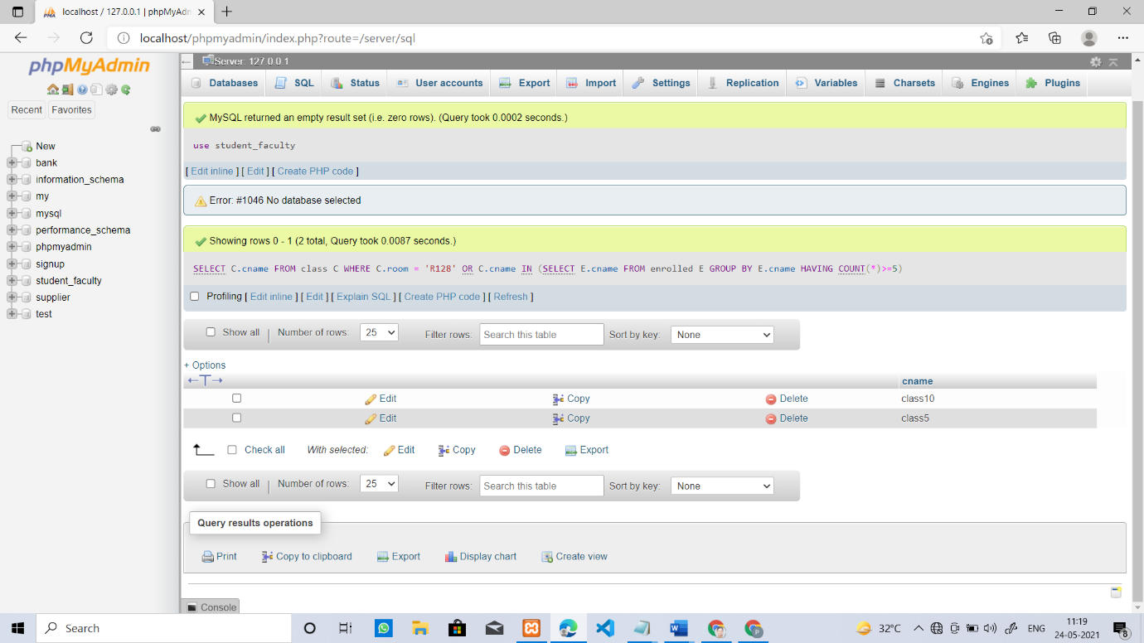

1. Find the names of all students who are enrolled in two classes that meet at the same time.

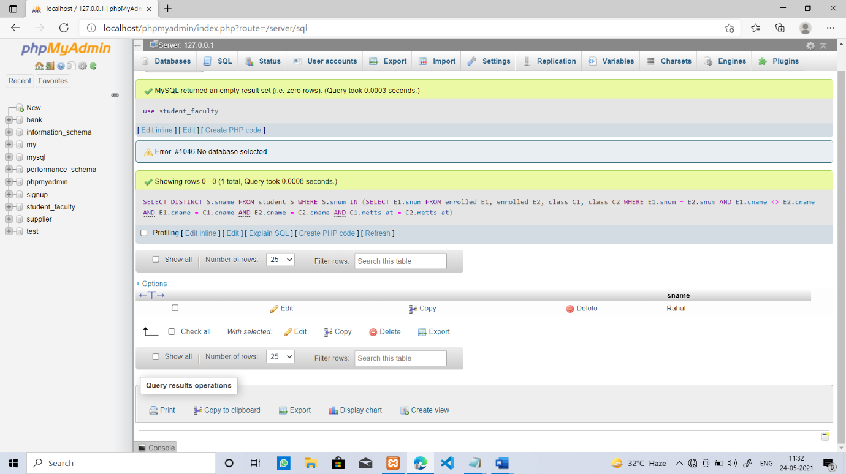

iv)